Mid Sussex Marlins guide to competing

When your child joined, they would have been registered with Swim England as a Cat 1 now known as Club train. This is for their training sessions they attend and any licenced Level 4 meets.

Licensed Meets are swimming events licensed by Swim England. This means they must meet certain standards to ensure fair competition. At the meet there will be qualified officials, all of whom are volunteers, having qualified officials is crucial to swimming. Without them, meets cannot be licensed and swimmers' times will not be officially recognised.
It is important to be aware that ALL licensed meets, from Club Champs through to the Nationals, are swum under the Swim England laws and regulations and the Swim England Technical Rules of Racing. This means that if a swimmer makes an error i.e., performs a false start, performs incorrect stroke technique, performs an incorrect turn or finish etc, they will be disqualified from the event and their time from the race will not be counted.

New swimmers starting out will need to gain their licenced times at Level 4 meets- i.e. –internal club championships. Please ensure if you get the opportunity, enter your child for as many events as you can- so they have times.

Once your child moves onto Open meets – outside of the club, they will need to be upgraded to a Cat 2 now known as Club Compete. You cannot enter a meet outside of the club without this.

These meets are mainly L3- there will be qualifying times from the meet host, and you will be emailed if your child is eligible to enter. The event will be on ‘Swim Manager’ under ‘Meets’.

 https://midsussex.swimmanager.co.uk/login

Swim Manager: - This is the parent Portal Mid Sussex Marlins uses as a Swimming Club; you will find- club records, your invoices, payments you have made, session sign ups, Events, Documents, Meets and much more.

Swim Manager makes it extremely easy for you to enter meets. Simply click the ‘Meets’ option in the Parent Portal and you will see a list of upcoming meets that you are able to enter. If you do not see a meet here, then it is likely to be for one of the following reasons:

1. Your Club has not yet opened entries for the meet.

2. The entry deadline has passed for this meet (meets are automatically removed from the list on this date).

3. Your swimmer is not in a Squad that this meet is targeted for To enter the meet, click the Enter Meet button. Meet Entry Form.

‘Meets’ is where you will need to enter your child if they are eligible for an ‘Open Meet’

If your child has made the entry time for an event this will show in Green, any of the events in Red with an ‘X’ means they have not made the entry time for that event, and they will not be able to enter.

If you wish for your child to enter a race, tick the box in Green, and at the top of the page press ‘Submit Entry’, the fees for the event are generated and you are invoiced accordingly. You cannot submit entries one at a time- submit all entries in one go.

See below of an example of what the Meet entry will look like on Swim Manager:-

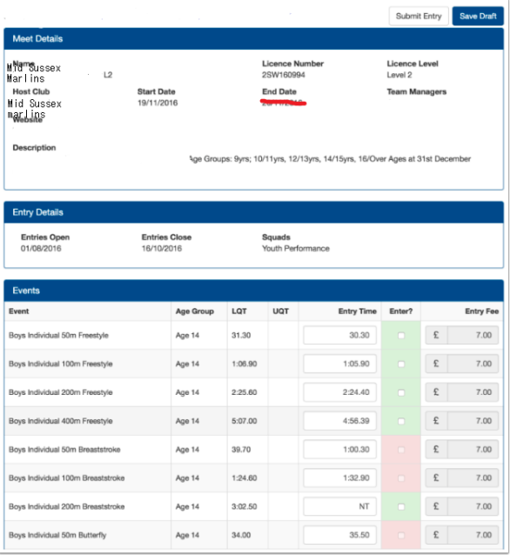

NT= NO TIME gained for this event- in most circumstances if the swimmer does not have a licenced time you are unable to enter the race-

Entry Conditions
- You will never be able to manually enter entry times. Entry times will come from previous licensed racing.
- The conditions of an away meet are set by the host club. We cannot request exemptions or variations.
- Submitting an entry means you accept the conditions.
- Once the host publishes “accepted entries” then there will not be any refunds for withdrawals, even if you are left with a sporadic and “isolated” mix of races.
- If you are rejected from an event, you will receive a credit on your Swim Manager account that can be used against future competition entries. You won’t lose the credit, but we won’t pay back the original payment because of high bank transaction charges.
- Level 3 meets will have upper qualifying times. You cannot enter if you are faster than these, this gives more opportunity to younger / slower swimmers to enter.
- Club entries close earlier than the host closing date so we have time to review and correct issues before submitting our entry to the host club.
- Some meets are “first come, first served” meaning our entries will close some time before the host club opens for entries. This ensures we are first in the queue and have least chance of rejection.
- Other meets are “fastest entry” meaning there is no advantage to entering early and we can wait for swimmers to gain better times before submitting our entry. However, these meets present more chance of being rejected from your slower strokes.

Open Meets – General Information
Open Meets are known as “Opens” because entry is open to any swimmer, from any club, who meets the qualifying times and age requirements. They are busy meets with anywhere between 200 and 300 (sometimes more!) swimmers in attendance. To enable as many events and swimmers as possible, Opens are held over one whole day, However, larger meets can be held over a whole weekend with the long-distance events (800m and 1500m freestyle) being held on an evening session only.
All Open meets have an entry form which needs to be completed by each swimmer and all host clubs charge a fee per event entered (for example £6.00 per event). Hiring a pool for a whole weekend, and hosting an open meet, is extremely costly which is why host clubs charge entry fees. Swimmers’ entry times are required for each event, and these must be shown on the entry form. The host club always provides a schedule of qualifying times and swimmers must ensure they meet these times before entering the meet.
Swimmers are seeded into heats for each event from the slowest to the fastest using their entry times. Usually, the ages are mixed but events will always be separated into male and female. Awards are made to the fastest swimmers in each event and age group – sometimes it’s the first three, sometimes the first six. Open Meets may choose ‘ages as at 31st December’ in year of competition or ‘age on the last day of competition’. Swimmers may be asked to sign-in for all their chosen events at the start of each session or a withdrawal system may be used instead, whereby swimmers are expected to sign-out of events they no longer wish to compete in.
Taking part in an open meet can bring a swimmer a great sense of achievement, especially if he or she achieves a personal best (PB) in one or more events. There is usually a team entered from the Club which makes for a social occasion and swimmers start to recognise and get to know swimmers from other clubs. Parents can also get to know one another by sitting together to cheer for their children. They can also support the Club by training to become an official or team manager.
Equipment
As well as obvious items like hats, goggles, towels and race suits/shorts, swimmers will need their Mid Sussex Marlins club shirt, a warm top such as a Mid Sussex Marlins hoodie and a pair of poolside shoes (trainers / sliders). Marshalling areas (where swimmers are gathered to be put into race order) can often be away from poolside, so sliders / flip flops / trainers are a must. But probably the most important thing to remember is enough food and drink to last for the whole event! Nobody likes a hungry swimmer!

Heat Declared Winner (HDW)
This term is used for events where there is no final. It means that awards will be decided after all the heats for an event have been swum. Confusion sometimes arises with heat declared winner events: it is NOT the winner of each HEAT who wins an award, but rather the fastest three swimmers of each AGE GROUP of each EVENT after all the heats have been swum.
Finals
At some large open meets there are finals of each event. These are always split into boys and girls and are usually per age grouping. The swimmers who will take part in a final are decided after all the heats of each event have been swum. They will be the swimmers who have posted the eight (depending on the number of lanes in the pool) fastest times in each age grouping in each event. These swimmers will be the ones receiving the awards – sometimes awards are presented to all finalists, but it could just be the fastest three in each final. If a swimmer does not make it into a final, he or she will not be receiving an award even if they won their heat.

Training sessions are not licenced- times cannot be gained in training sessions for meets.

Guide to the four levels of licensed meets
All licensed meets are subject to Swim England Regulations and the Swim England Technical Rules of Racing. They are graded into four levels.
- Level 1 Meets are long course (50m) only and cover National, Regional and County Championships. Their purpose is to enable athletes to achieve qualifying times for entry into National, Regional and County Championships.
- Level 2 Meets are short course (25m) only and cover National, Regional and County Championships. Their purpose is to enable athletes to achieve qualifying times for entry into National, Regional and County Championships in short course.
- Level 3 Meets are long and short course events. Their purpose is to enable athletes to achieve times for entry into Regional and County Championships and other Meets at Level 1 or Level 2.
- Level 4 Meets are entry level events in pools 25m or greater. Club Championships are an example. They are for inexperienced athletes and swimmers seeking to compete outside their club environment. If times are good athletes progress to Level 3 Meets.

From 2022 the registration details are as follows:-
Existing Name | New Name | Category Descriptor
Category One | Club Train | For individuals in a club who are either learning to swim, or training in any discipline. As a Club Train member, you will be able to compete in Low Level Competitions (club championship) or an event that has an exemption under Swim England regulations.
Category Two | Club Compete | For individuals who are part of a club and looking to compete in any discipline in open competitions. This membership offers you the benefit of structured competitive pathway at all levels in every discipline
Category Three | Club Support | For anyone involved in a club who volunteers or is employed by the club, including committee members, officers, Teachers and Coaches as well as any parent members.

Thankyou
Lorraine

